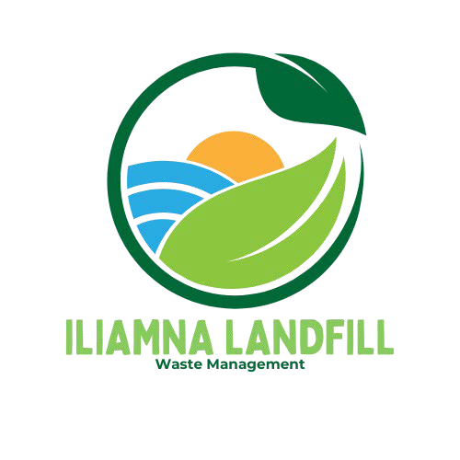

# Construc�on and Demoli�on Waste Disposal Informa�on

Applicability

Before a demoli�on or renova�on project begins, federal regula�ons require the iden�ﬁca�on of any asbestos-containing materials (ACM) or other hazardous materials in the structure. A person trained to iden�fy poten�ally hazardous materials must

conduct and record a building survey of the structure and any contained materials. For all demoli�ons of commercial structures, ins�tu�onal structures, or residen�al structures with more than four units, federal law requires you submit no�ce to EPA at least 10 days before any demoli�on begins regardless of the presence of hazardous

materials or ACM.

All hazardous materials must be removed and properly disposed prior to demoli�on. In par�cular, ACM must be removed, managed, and disposed in compliance with the Environmental Protec�on Agency (EPA) Na�onal Emissions Standards for Hazardous

Air Pollutants (NESHAP) requirements [40 CFR 61, subpart M]. Workplace safety standards and disposal requirements require any contractor to iden�fy and properly manage all ACM; however, the NESHAP standards only apply to commercial structures, ins�tu�onal structures, or residen�al buildings with more than four units.

Prior to 1983 a variety of construc�on materials contained asbestos ﬁbers. Although some uses were restricted in 1983, asbestos can s�ll be found in wallboard, ﬂooring materials, rooﬁng materials,

mas�cs, thermal protec�on, and cement products. This policy also applies to the

disposal of camper trailers, mobile homes, residen�al boats, and similar structures manufactured prior to 1983.

For the purposes of this policy, all the above listed structures are considered “buildings”. Prior to disposing of waste generated by the complete or par�al demoli�on of any building/structure that was constructed or manufactured prior to 1983, a building

survey must be performed by a qualiﬁed individual. The building survey must determine if the building contains any asbestos or other hazardous materials. In addi�on, tes�ng is required for lead based paint waste generated from ‘non-residen�al’ sources.

Hazardous materials, or other wastes that may cause a poten�al hazard to human health or the environment, o�en require special handling and disposal methods under

federal laws, including the Resource Conserva�on and Recovery Act (RCRA), the Toxic Substances Control Act (TSCA), and the Low-Level Radioac�ve Waste Policy Act (LLRWPA). Hazardous wastes commonly found in a demoli�on project include:

* Lead-based paint
* Lead pipe and solder
* Fluorescent tubes and bulbs
* Mercury switches and thermostats
* Paints, solvents, or pes�cides
* PCB-containing transformers or light ballasts
* PCB-containing paint or caulking
* Radionuclide-containing smoke detectors and exit signs
* Refrigerants from air condi�oning units.

**Toxicity Characteristics Leaching Procedure (TCLP)**

The U.S. Environmental Protec�on Agency (EPA) has iden�ﬁed 40 toxic chemicals that can cause harm when products containing them are disposed in landﬁlls and the chemicals leach out (40 CFR part 261). To determine the poten�al of speciﬁc wastes to leach dangerous

concentra�ons of toxic chemicals into groundwater, the EPA developed a protocol known as the Toxicity Characteris�c Leaching Procedure (TCLP).

Products containing one or more of the listed toxins are assessed using the TCLP to es�mate how much of their toxic contents would be released into landﬁll leachate under ordinary condi�ons. If the amount of a par�cular chemical released under test condi�ons exceeds regulatory limits, the waste qualiﬁes as hazardous and must be handled according to regula�ons governing hazardous waste, such as handling by cer�ﬁed disposal agents and recycling or disposing in specially designated landﬁlls and incinerators. Products that do not leach toxic materials at levels exceeding regulatory limits are termed TCLP compliant.

*Alaska does not have any landﬁlls permited to accept regulated hazardous wastes.

# Asbestos

Any poten�al ACM iden�ﬁed in the building survey must be sampled and tested; if it contains more than 1% asbestos, it must then be categorized as friable or regulated ACM (RACM), or as Category I or Category II non-friable ACM, which are o�en referred to as non-RACM. These categories determine how the materials must be managed during removal and disposal.

Failure to properly iden�fy, remove, and dispose of ACM can expose workers and the public to asbestos ﬁbers, and facility owners and contractors to civil and criminal liability.

Lead-based paint (LBP) was commonly used in residen�al, commercial, and ins�tu�onal

buildings un�l 1978. Lead presents a health risk, par�cularly in young children. Projects genera�ng ‘non-residen�al LBP’ are required to include lead-based paint tes�ng in the building survey. ADEC deﬁnes ‘non-residen�al LBP’ as “LBP generated during the renova�on or demoli�on of nonresiden�al structures,” OR “LBP from the demoli�on of a residence; this does not include LBP generated as a result of a renova�on or remodeling of a residence.”

Please see KIB Asbestos Disposal Informa�on, Revised 10 February 2022 for more informa�on on asbestos disposal requirements.

# Lead-Based Paint

If LBP from a ‘non-residen�al’ source is present, the paint must be sampled and tested as outlined below.

* + LBP must be sampled and analyzed using the toxicity characteris�c leaching procedure (TCLP) test for lead as required by the ADEC and Environmental Protec�on Agency (EPA). Other LBP tes�ng methods, such as x-ray ﬂuorescence analysis and home-based lead test kits, will not provide the KIB with suﬃcient informa�on to determine if the LBP waste is acceptable for disposal.
  + The TCLP test must be conducted by a lab cer�ﬁed to conduct lead analyses (EPA Method 6020). Please refer to the Alaska Department of Environmental Conserva�on (ADEC) website for a list of cer�ﬁed labs.

Wastes with a TCLP concentra�on for lead of greater than 5 mg/L must be managed as a hazardous waste under the Resource Conserva�on and Recovery Act (RCRA).

# Abrasive Blas�ng Material

Abrasive blas�ng is the use of abrasive material to clean or texturize a material such as metal or masonry. Sand is the most widely used blas�ng abrasive. Other abrasive materials include coal slag, smelter slags, mineral abrasives, metallic abrasives, and synthe�c abrasives. Industries that use abrasive blas�ng include the shipbuilding industry, automo�ve industry, and other industries that involve surface prepara�on and pain�ng. Spent abrasive blast material may contain a variety of pollutants. **Due to this high possibility, the KIB landﬁll is currently not accep**�**ng any type of spent material.**

* **The Borough has the discre�on to refuse any waste coming to the KIB landﬁll.** If material is ques�onable the KIB can require addi�onal tes�ng to ensure the material meets permit standards.